HOME.LLC ASSIGNMENT

**FACTORS THAT COULD INFLUENCE RESIDENTIAL HOME PRICES ACROSS THE UNITED STATES OVER THE NEXT 10 YEARS**

BY - SEEMA ACHARYA

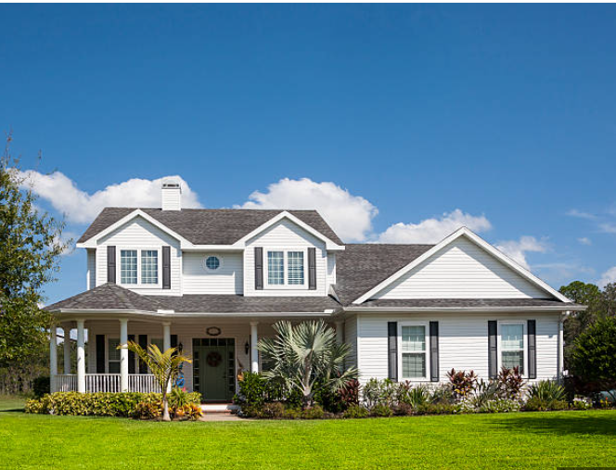

**Introduction**:-

This report describes in a **mutually exclusive and collectively exhaustive** format on all the factors that could influence residential home prices across the United States over the next 10 years.

**Brief:-**

1. The Real estate market most especially the residential homes and their prices are grossly influenced by a lot of things. Things like interest rates, population density changes, the economy, market cycles, consumer behaviour and the likes plays a key role in influencing the prices of homes in any demographic region. For the sake of this report, I have restricted my analysis to just the United States.

**5 Factors that influence prices of residential homes in the United States**

**1. Income**: The average income of people living in a particular area is one of the most defining factors of the prices of homes in that area. Houses around major cities and states where people tend to earn more are usually also costlier than houses in rural areas.

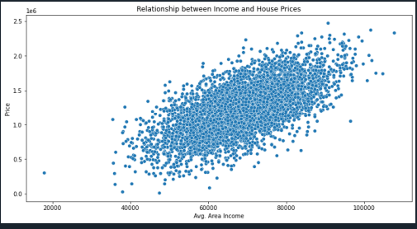

2. **Location** :

Residential houses are usually more costly where there are

1. Better Employment opportunities
2. More people(High population)
3. Close Malls, Entertainment centres, schools etc.

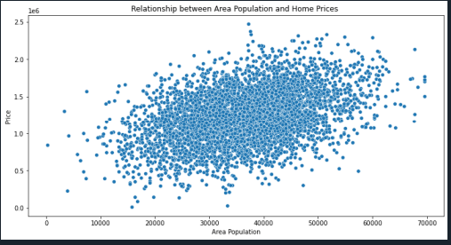

All these factors influence the prices of the house.

1. **Number and Sizes of the rooms:**
   1. 1 bedroom flats are on average, relatively the costliest flats. After that prices of residential apartments rise linearly from two to eight with its peak at eight then falls back from 9 onwards.
   2. The price of a house tends to increase with the number of bedrooms available. 3 bedrooms are on average, comparatively on great demand.
   3. Even though people tend to pay more for houses with more area of number of rooms. They are also other factors that would also

affect the price.

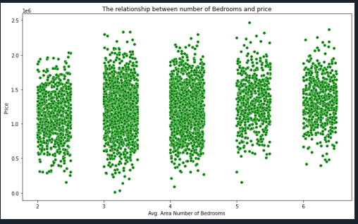

1. **Age and State of the house**: Houses that were built recently are usually costlier than older houses and people tend to pay more for houses that were just recently renovated.

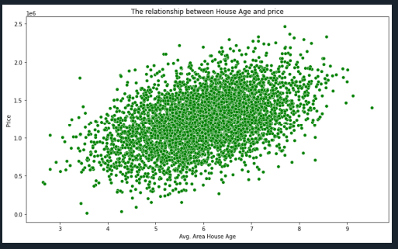

1. **Views and Asthetics**: Houses with beautiful views tend to be more costlier.

The general condition of the house so the little factors like bulbs, toilets, kitchen and all that can go a long way in determining the value of the house. There are also the major influencing factors that might affect the prices of residential houses such as the neighbourhood it’s in, the interests rates of the house, the current economy and so on.

Kindly access the file below if you’d like to view the code I used for the analysis behind my report.

**https://github.com/seemaacharya/Home_Price_Analysis_USA/blob/main/House_Price_Analysis_USA.py**